***iPlanner***

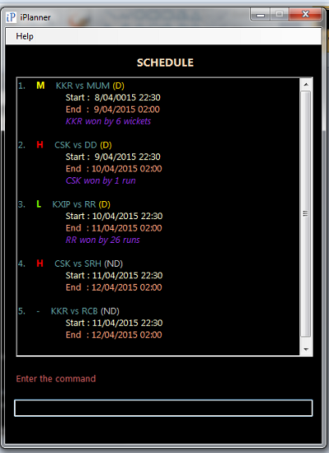

**Supervisor:** Huang Da **Extra Feature:** Automated Testing

|  |  |  |  |  |
| --- | --- | --- | --- | --- |
| C:\Users\HP\Desktop\Semester 4\CS2103 Software Engineering\Profile Picture.jpg | C:\Users\HP\Desktop\Semester 4\CS2103 Software Engineering\Project\Profile - Lee Joon Fai.JPG | ***https://lh5.googleusercontent.com/EfoECgOx8Eww5GvYGyMJkbJcR0iNNBodKoEbiLFTTSiu7T5vCD-6mLILABvVqGWJmc3V8t00s6WgwckKq4flrIG9MogWkha0zBrLNN1vGPBn4LEkP-OCwBBsNZn-9CvvrUY*** | C:\Users\HP\Desktop\Semester 4\CS2103 Software Engineering\Project\Profile - Ng Chon Beng.jpg | C:\Users\HP\Desktop\Semester 4\CS2103 Software Engineering\Project\Profile - Shri Kishen Rajendran.png |
| Andy Soh Wei Zhi | Lee Joon Fai | Yu Youngbin | Ng Chon Beng | Shri Kishen Rajendran |
| Documentation  *Code Quality* | Integration  *Documentation* | **Team Lead**  Scheduling*  *Testing* | Testing  *Integration* | Code Quality  *Scheduling\** |

* Role includes scheduling, tracking, and ensuring adherence of deliverables to deadlines.

# User Guide

Welcome to iPlanner – planning and scheduling at your fingertips!

iPlanner is a light and user-friendly task managing software, targeted at the busy individual who requires an efficient way of managing tasks on a desktop or a laptop PC, even when offline. This quick-start guide will bring you through the features provided by iPlanner, everything at your fingertips!

## The User Interface

iPlanner’s user interface is geared towards providing users with fast, understandable, and easily-understood feedback. Control of iPlanner is done completely via keyboard, and the entering of commands to iPlanner is easy to pick up.

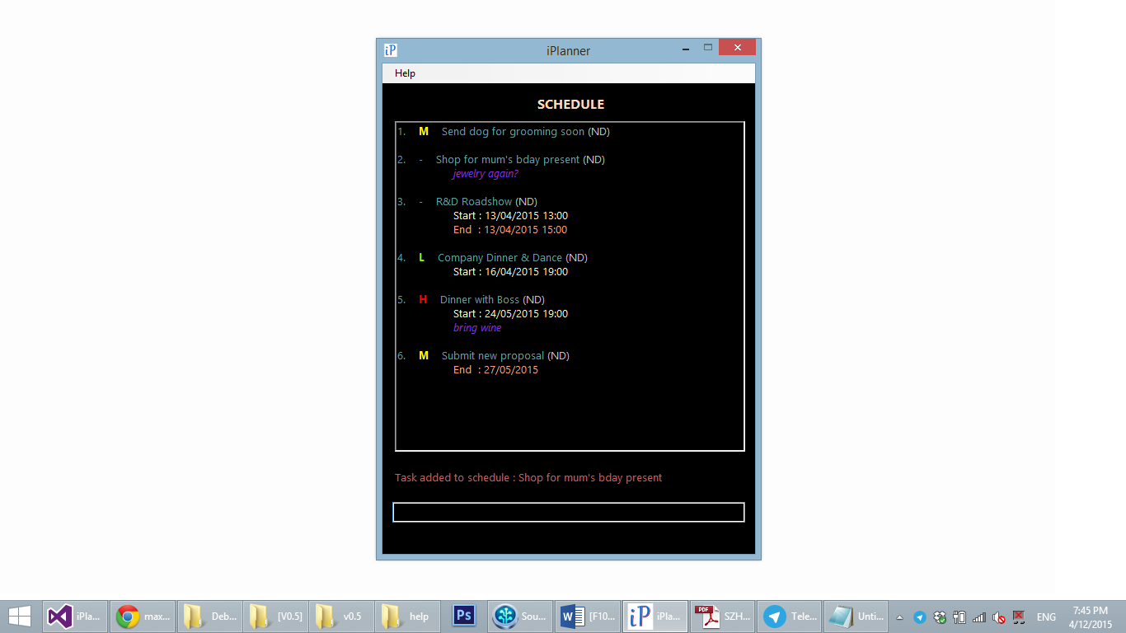

The image above shows how items are displayed in iPlanner. An item has up to six fields to save information, namely Name, Description, Start Time, End Time, Priority, and Completion. The different fields have also been colour-coded to ensure easy recognizing of elements that are important (e.g. High priority items).

## How Commands Work

iPlanner supports entering multiple relevant commands in the same line. For example, entering:

*add Boss’s birthday party -start 15/03/2015 1300 -end 15/03/2015 1430 -desc 24 Kent Ridge Park, buy present -priority H*

adds a new event, titled “Boss’s birthday party” from 15 March, 1pm to 15 March, 2:30pm, with additional information specified by the user – including location (Kent Ridge Park) and a task to do (buy a present). Additionally, the event is marked as high priority.

### Main Commands

Main input commands:

* add - Add a new item into iPlanner
* del/delete - Remove an item from iPlanner
* edit - Edit the field(s) of an item in iPlanner

Main display commands:

* search - Search for a keyword/phrase within the items in iPlanner
* sort - Sort the items on display according to date/name/priority
* view - View only items meeting the condition (high priority, range of dates, all, etc.)

Other main commands:

* clear - Removes all currently-displayed items from iPlanner
* undo - Undo the last undo-able action (add/delete/edit/clear)
* exit - Exits iPlanner

### Sub-Commands

Input sub-commands: The following commands can be used after the ‘*add’* or ‘*edit’* commands to configure the fields of the item being added/edited.

* -desc - Configure item description
* -start/-date - Configure item start date/time
* -end/-due - Configure item end date/time
* -priority - Configure item prioirity
* -remove/-rmv - Remove a field from the item (only for ‘*edit’*)

Furthermore, in the case where you accidentally type in more than one space between commands and texts, the programme will still be able to recognise the input.

## Add New Item

Create a new item by entering *add [name of item] followed by the sub-command(s)* in the user interface.

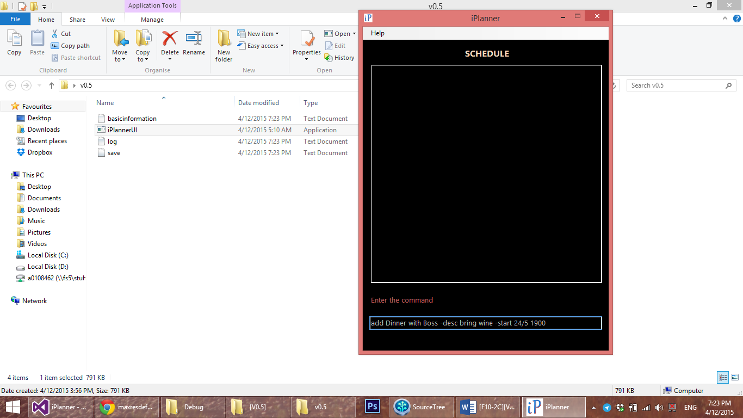

## Edit Item

Edit an existing item by entering *edit <display index of task to be edited> followed by sub-command(s) of item entity to be edited* in the user interface.

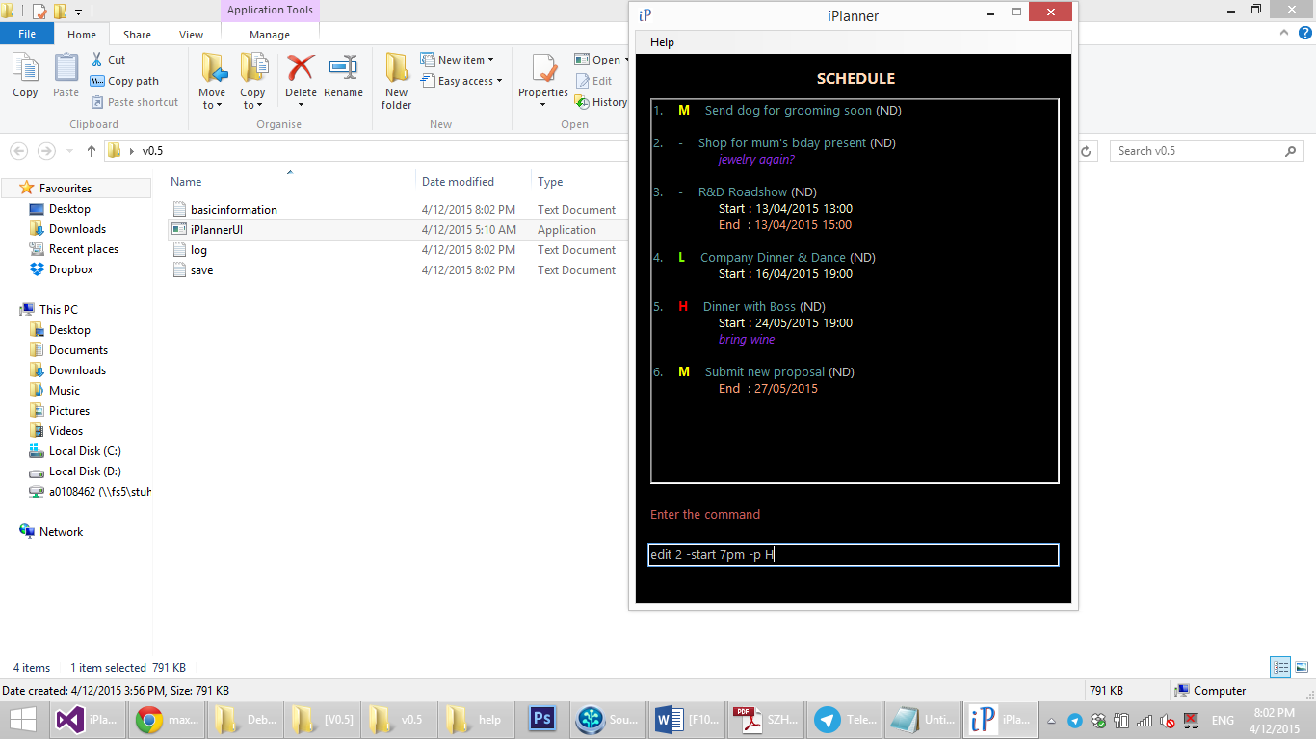

## Delete Item

Delete an existing task by entering *delete <display index of task to be deleted>* or *del <display index of task to be deleted>* in the user interface.

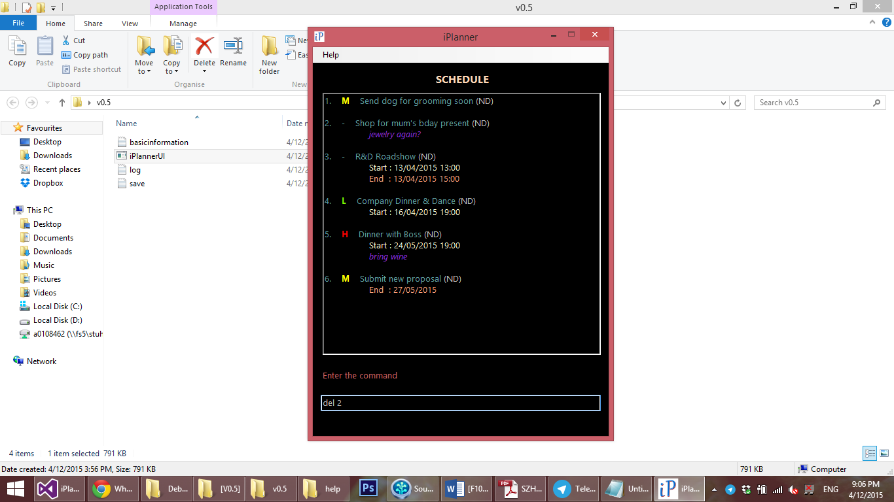

## Assign Timings – *start/date* and *end/due*

In iPlanner, items are categorized into Events (with specific start and end dates/times), Deadlines (with specific due dates/times) and Tasks (without specific dates/times attached). When adding a new item or editing an existing one,

1. Specify start time by entering *-start <dd/mm/yy hhmm>* or -date *<dd/mm/yy hhmm>*
2. Specify end time by entering -*end <dd/mm/yy hhmm> or* -*due <dd/mm/yy hhmm>*

### Flexible date and time formats

iPlanner also supports the input of date and time in flexible formats. A list of supported formats and examples are listed below.

#### Date & Time variations

* 27/12/2015, 17:00 *<date>, <time>*
* 17:00, 27/12/2015 *<time>, <date>*
* 27/12/2015 *<date>* only
* 17:00 *<time>* only, date is set as current date

#### Date variations

* 27/12/2015 *<dd/mm/yyyy>*
* 27 December 2015 *<dd MonthName yyyy>*
* 27 Dec 2015 *<dd ShortMonthName yyyy>*
* 27/12 *<dd/mm>*, year is set as current year
* 27 December *<dd MonthName>*, year is set as current year
* 27 Dec *<dd ShortMonthName>*, year is set as current year

#### Time variations

* 17:00 or 1700 *<hh:mm>* or *<hhmm>* (24 hour format)
* 5:00pm or 500pm *<hh:mm>am/pm* or *<hhmm>am/pm* (12 or 24 hour format)
* 5pm *<hh>am/pm* (12 or 24 hour format)

## Adding Descriptions – *description/desc*

When adding a new item or editing an existing one, additional details or descriptions of the items can also be added by entering *-description <description>* or *-desc <description>* in the user interface after a main input command (add or edit). This may include the location of the event, *e.g. Singapore Flyer*, and other relevant details, *e.g. bring a rose, wear a bowtie*. Note that <*description>* will take on the user’s input until the end of the command line or the beginning of a different sub-command.

## Assign Priority – *priority/p*

When adding a new item or editing an existing one, assign priority to an item by entering *-priority <priority level>* or *-p <priority level>* in the user interface after a main input command (add or edit). Note that priority can only take on the values of low, medium, or high, and <*priority level>* in the user interface can be entered as *low*, *medium* or *high* or *L*, *M*, or *H*.

## Remove Item Field – *remove/rmv*

While editing an item, you can choose to erase the information in the description, start time, end time, and priority fields.

* Remove Description – Remove only the item description by entering *-remove description/desc* or *-rmv description/desc* in the user interface.
* Remove Start Time – Remove only the item start time by entering *-remove start* or *-rmv start* in the user interface.
* Remove End Time – Remove only the item end time by entering *-remove end* or *-rmv end* in the user interface.
* Remove Start and End Times – Remove both the start and end times by entering *-remove date* or -*rmv date* in the user interface.

## Mark Done/Undone – *done* and *undone*

You can mark an item as “Done” by entering *done <task index of task completed>*. User can mark an item as “Not Done” by entering *undone < task index of task completed >*.

## Undo Previous Action – *undo*

Undo the previous undo-able action by entering *undo* into the command line interface. Only add, delete, edit and clear commands are undo-able.

## Search – *search*

Search for an existing item by entering *search <keywords>* in the user interface. Note that *<keywords>* will take on the user’s input until the end of the word, and only results that match the entire string, will be returned.

Multiple strings may be searched by including a '+' in between two words to be searched. For example, *search <keyword1>+<keyword2>+<keyword3>*

## Sort Items – *sort*

The items may be sorted by name, date, priority, completion and update order.

* Sort by Date – The default arrangement of events/deadlines is chronologically, with the earliest ones displayed first, i.e. an event on 4 Jan 2015 will appear before an event on 14 Feb 2015. Tasks (without timestamps) will appear at the beginning. Revert to this arrangement by entering *sort date* in the user interface.
* Sort by Name – Sort items by their names by entering *sort name* in the user interface.
* Sort by Last Update – Sort items in the sequence that they have been updated by entering *sort update* in the user interface.
* Sort by Priority – Sort items in order of priority by entering *sort priority* (or *sort p*) in the user interface. High-priority items will appear first, followed by medium-priority ones, followed by low-priority ones. Items without priority indicators will appear last.
* Sort by Completion – Sort items in order of completion by entering *sort done* in the user interface*.* Items that are not completed are displayed first, followed by items that are completed.

## View Items – *view*

The items may be filtered according to date range, priority, and completion.

* View All – All items in the Schedule can be viewed by entering *view all* in the user interface.I
* View Range of Dates – Items between two dates can be viewed by entering *view <date1> <date2>* in the user interface. Events starting, ending, or spanning between that time period and deadlines on that day will be returned.
* View by Priority – View only high-priority, medium-priority, or low-priority items by entering *view High* (or *view H*), *view Medium* (or *view M*), *view Low* (or *view L*) respectively into the command line interface.
* View by Completion – View only items that have been done or that have yet to be done by entering *view done* or *view undone* respectively into the command line interface.

## Storage – *save*

When the program is executed for the first time, the schedule is stored, by default, in the same folder as the executable file.

* Change Save Directory – The save directory can be changed by entering *save <new directory to be saved>* in the user interface.

## Help Menu

A comprehensive help menu detailing all the commands supported by iPlanner and variations of the input format can be called from within iPlanner.

* View Help Menu – View the list of commands supported, their specifications, and syntax by pressing *Alt, Enter* in the user interface. The help menu can be scrolled through using the arrow keys and Enter button.

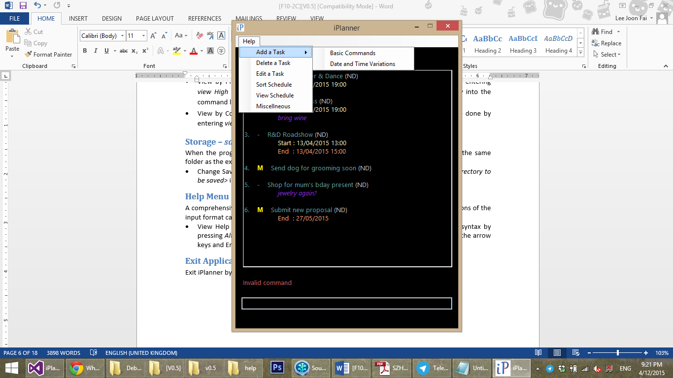

## Exit Application

Exit iPlanner by entering *exit* in the user interface.

# Developer Guide

At this point in time, we have implemented the most basic functions (Create, Read, Update, Delete), and have set up the preliminary skeletons and code for other more advanced ones (Sort, Search, Filter, etc.) although the latter are not fully implementable at this period in time. Additionally, plans have been made to modify some of the current implementation and APIs in order to conform more closely to the Object Oriented paradigm. In the following section of the guide, an overview of the project is provided.

## Architecture

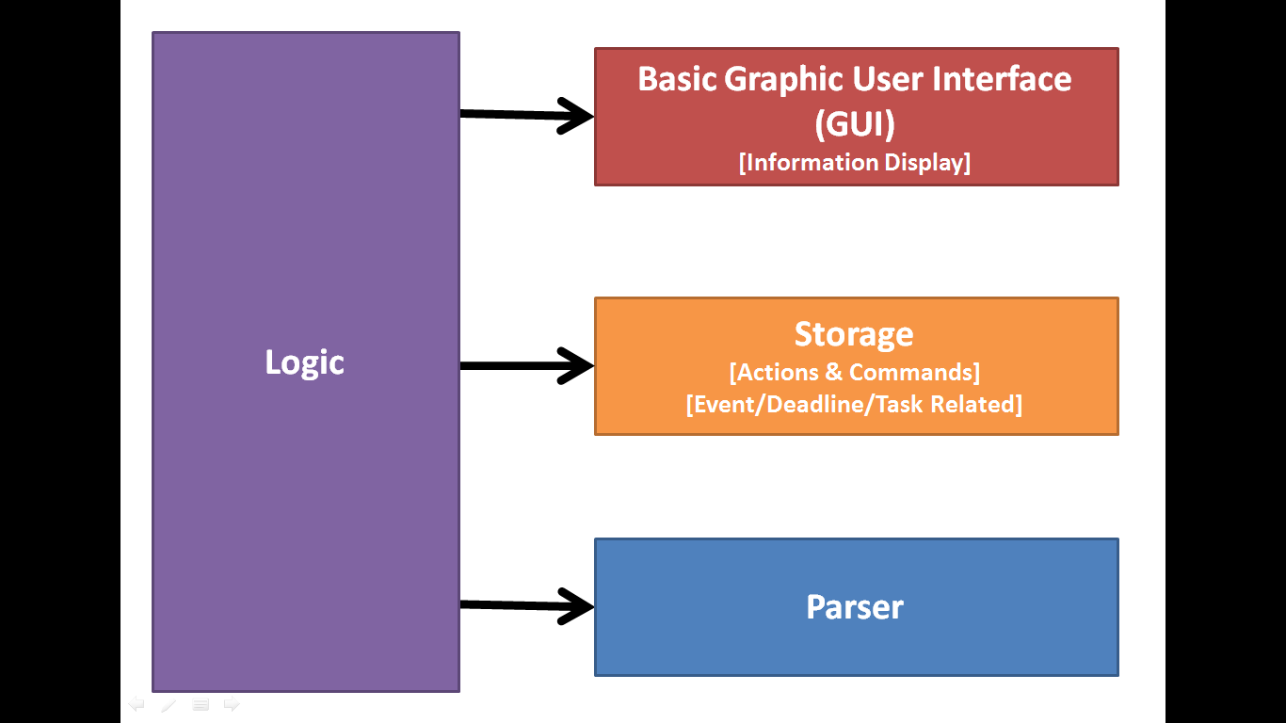

## Sequence Diagrams

1. Assuming that no exceptions occur and all cases are valid, after the user enters input in the User Interface, the input string is passed to the Logic component, which goes on to pass it to the Parser component.
2. Parser decomposes and interprets the input string, returning the parsed command back to Logic in the form of an Instruction object.
3. According to the instructions received from Parser, Logic will either
   1. Add: Create a new Item and pass its address to Storage,
   2. Delete: Instruct Storage to delete and existing Item,
   3. Edit: Retrieve a copy of an existing Item, make necessary changes to it, and pass the address of an edited Item to Storage to replace the old Item.
4. Once Storage has made its necessary changes, it returns a Success message back to Logic.
5. Upon receiving Success confirmation from Storage, Logic calls Storage again to retrieve a copy of vector of Items that will be displayed to the user.
6. Logic passes this vector to UI, along with the Success message, in a Feedback object.
7. UI displays a message to inform the user about the completion of the action and displays the contents of the vector.

### Addition of Valid Item

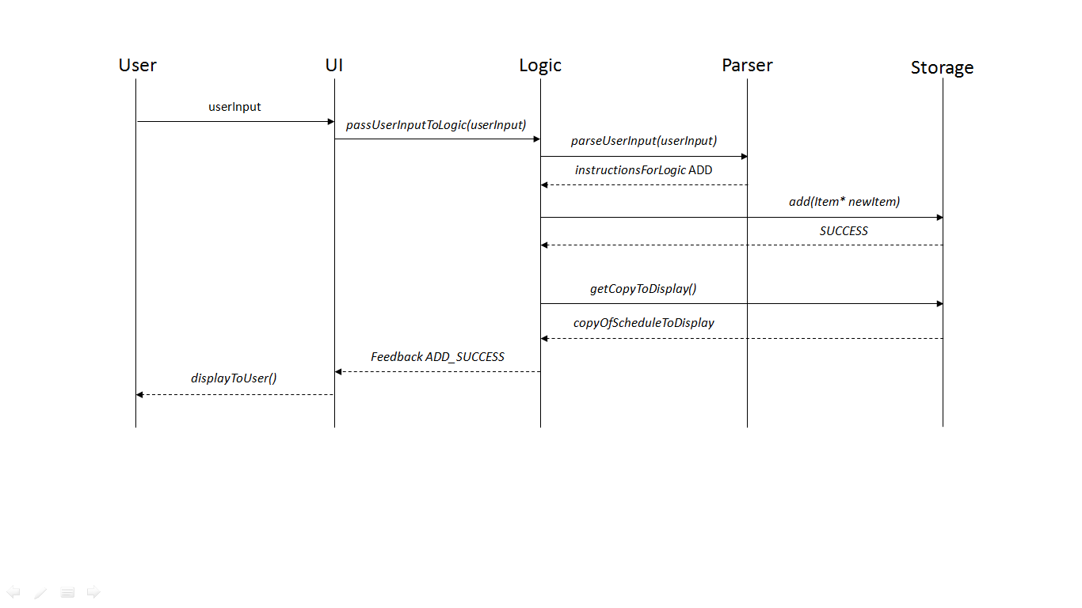

### Deletion of Valid Item

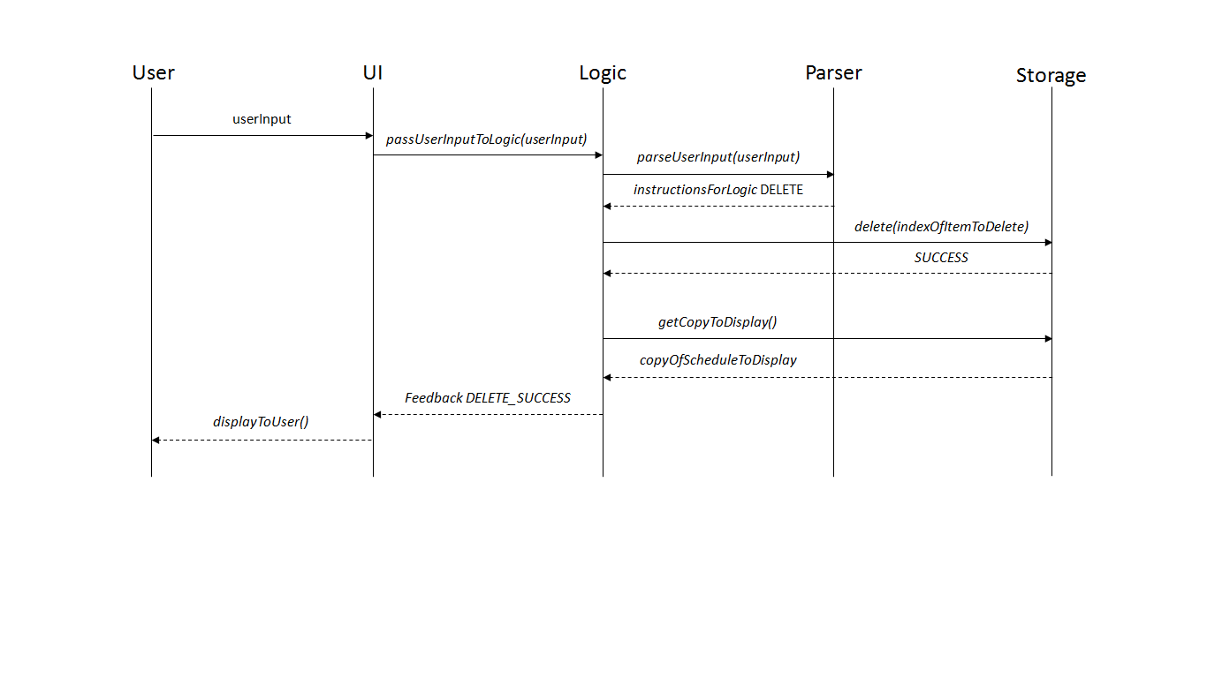

### Editing of Valid Item

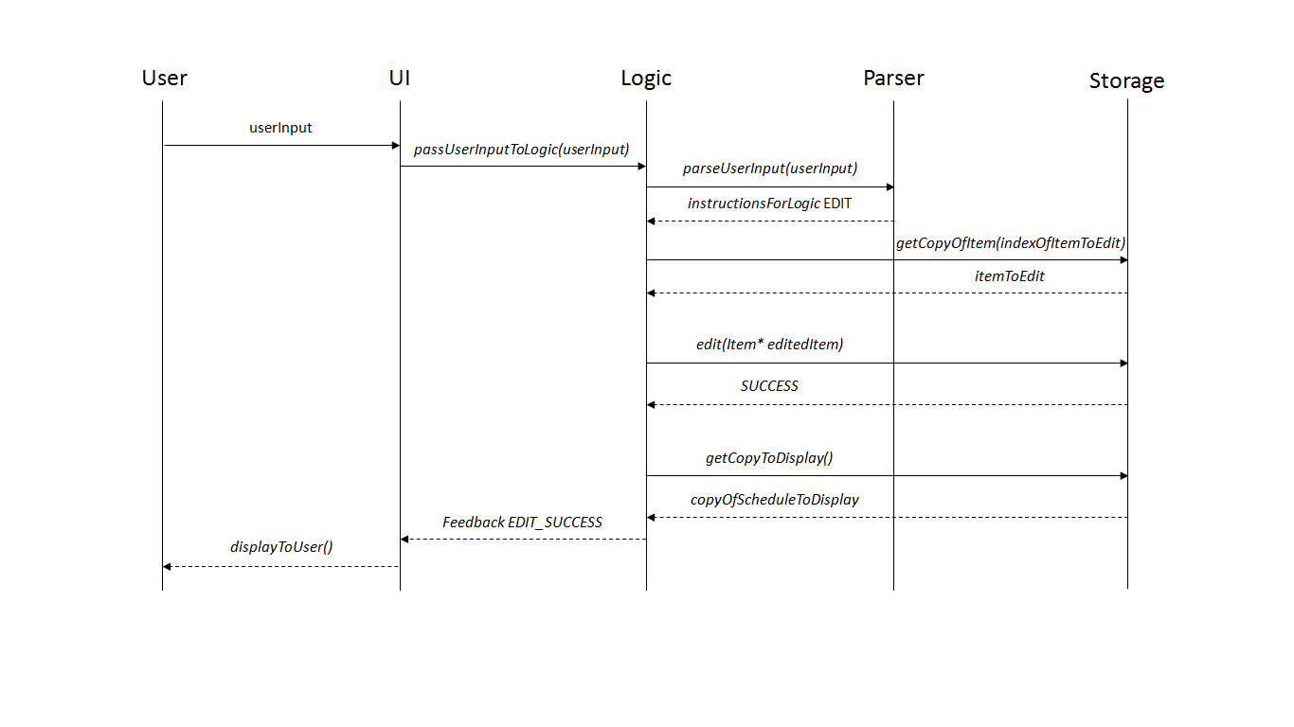

### Addition of Invalid Item

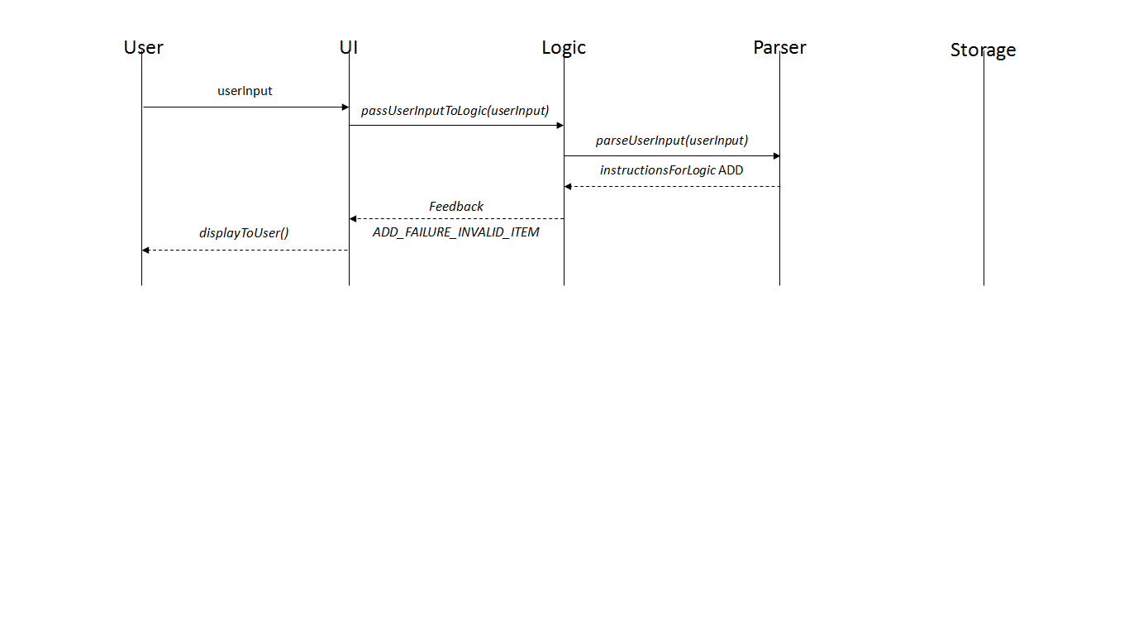

### Deletion of Invalid Item

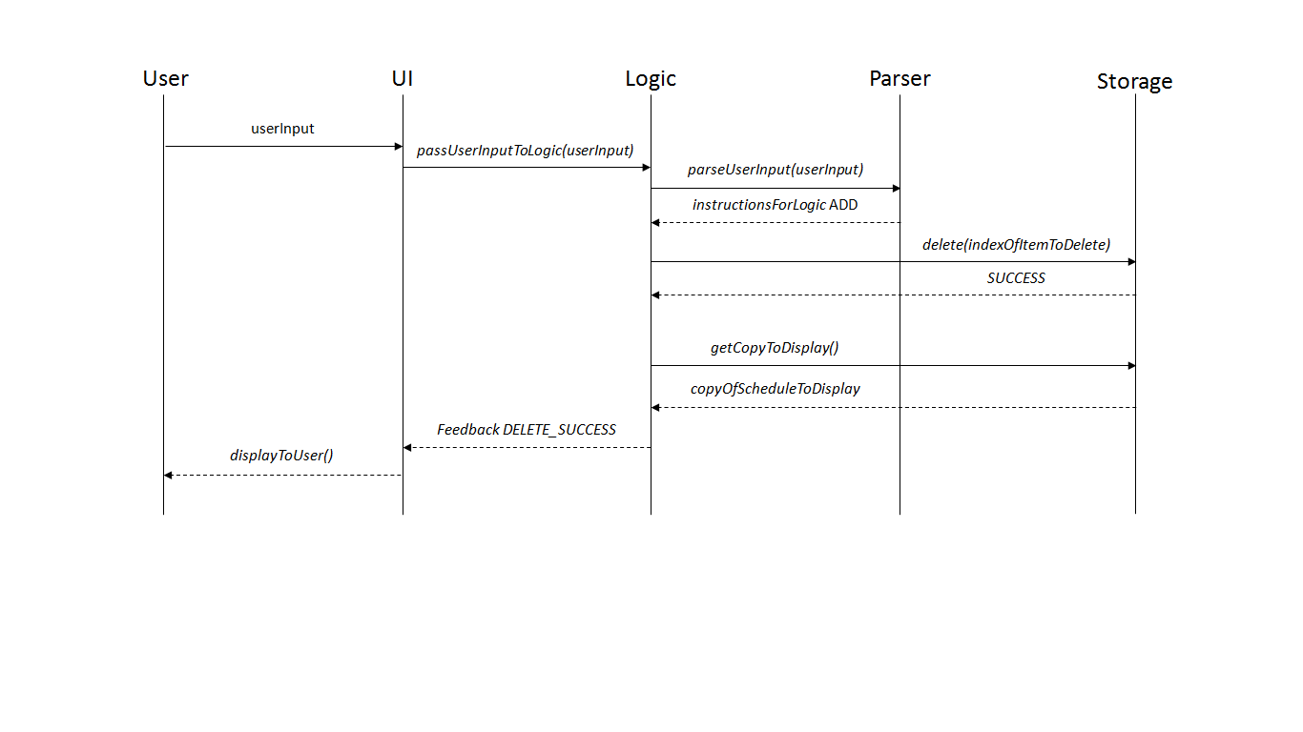

## User Interface

A basic graphic user interface is implemented. The User interface passes the command entered to Logic which processes the command entered by the user. Logic returns a vector of Items to be displayed and the outcome of the command as an outcome string. The vector of Items is displayed as the Schedule and the outcome of the command is displayed to the user.

The User Interface also shows the list of commands that the user can write, with their syntax, for the user's reference.

## Logic

Logic calls for a parser to get command. It executes basic functions like add, delete and edit depending on *parseInfo* given by the parser. Upon receiving *parseInfo*, logic calls *ItemVerification* to check whether the parsed item is valid to execute certain function. And finally, if the item is verified, logic is given access to schedule and modify it appropriately.

For now, logic is granted to access schedule and item and to make changes directly. However, from V0.2 onwards, logic will only be able to pass the address or pointer to *Schedule* and only *Schedule* will make the necessary adjustments.

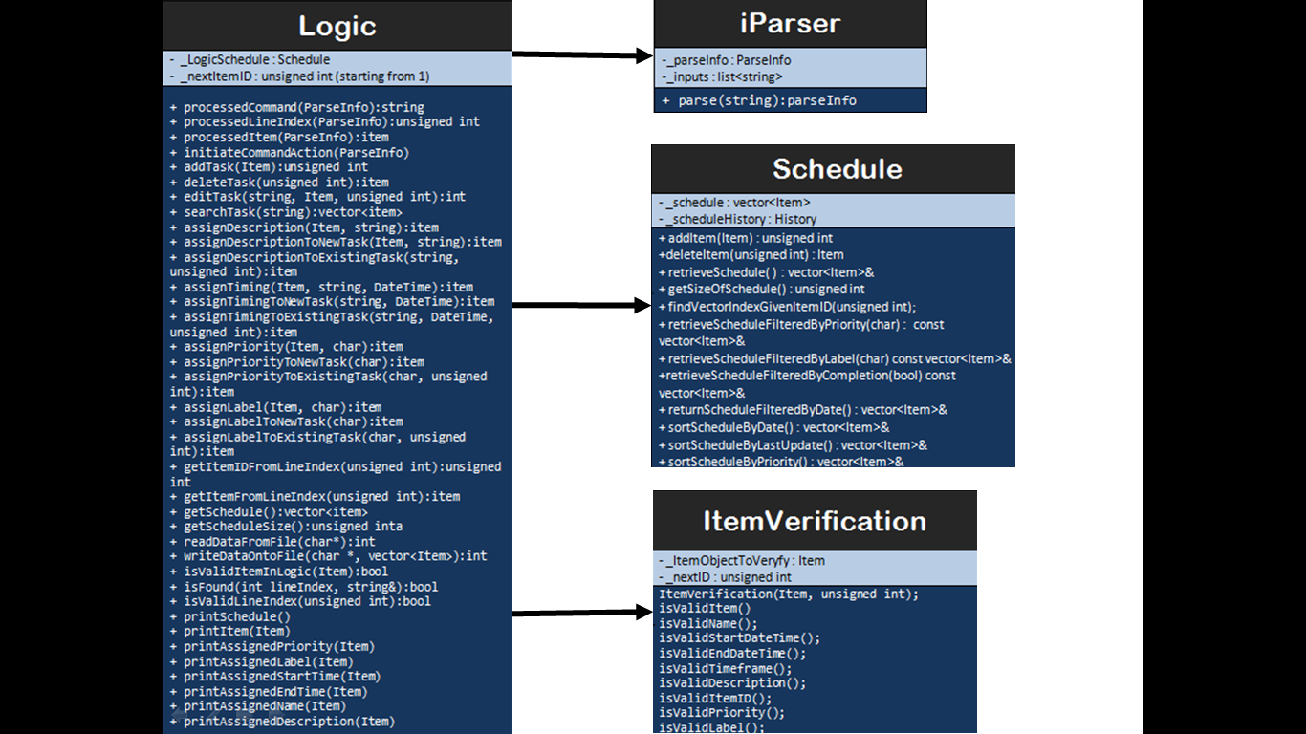

## Parser

Parser receives user input passed as a string data type and parser’s job is to split the user input into the respective commands and texts. Each user input is identified by the token “::”. It is to be noted that the strings split must contain a command but is not necessary accompanied with a text. With each split strings, the parser does a check in the command type and adds the data into *ParseInfo* class attribute.

As the *Parser* class is only required to accept a string data type and return the split information to *Logic*, all functions will be set as private functions with only one function, parse, accessible by *Logic*.

For future development, it will be better for *Parser* to return a list of commands and texts to *Logic*. The list will contain string data types which have been interpreted from the user input. This list of string will allow *Logic* to identify what function to execute.

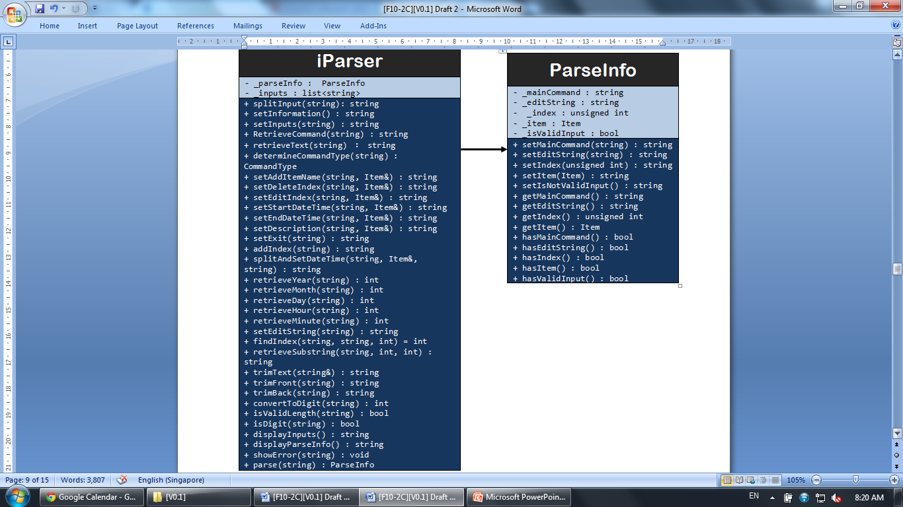

## Storage

Storage is currently implemented in the most basic and straightforward method – declaring and calling objects of a certain class. Each of the currently implemented sub-components – *Schedule*, *Item*, and *dateTime*, has the basic setters (used to assign values during *add* and *edit* functions) and getters (used extensively in *display* and *edit* functions). *Schedule* is slightly more functional with certain types of sorting implemented.

However, moving forward, it is important to implement storage as via pointers to objects, and in order to implement OO fully, logic will only pass values/pointers/objects to *Schedule*, and will not directly access the *Item* or *dateTime* objects via the getters (pass by reference). Local copies will be passed via the getter methods.

For the Storage component, test-driven development has been employed in most parts (exception to Schedule). Current tests are fairly comprehensive, although more efficient methods should be written in future to better compare between class objects (overload of Boolean == and !=, for example). This would allow better and less time-consuming usage of *Assert::AreEqual (... , ...)*.

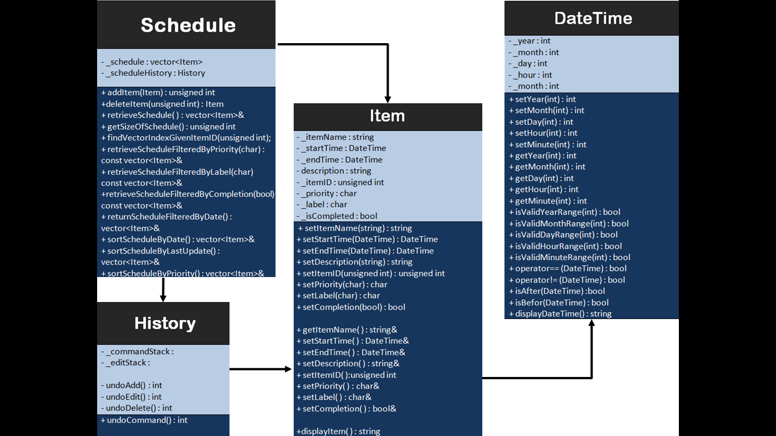

# Appendix A: User Stories. As a user, ...

## [Likely]

|  |  |  |
| --- | --- | --- |
| **ID** | **I can … (i.e. Functionality)** | **so that I … (i.e. Value)** |
| addTask | add a task by name of task only | can record tasks that I want to do a certain day or some day |
| editTask | edit a task by changing details of an already created task | make changes to the details of the task should there be any |
| removeTask | remove a task that had been added earlier | delete a task that is no longer required to be done |
| rescheduleTask | reschedule a task by changing the deadline or time of an already created task | make changes should there be any |
| undoLastAction | undo a single action which was previously done (e.g. add/ remove/ reschedule etc) | do not have to delete and remake the whole schedule one more time |
| specifyDeadline  specifyTimedTask | specify a deadline or time for a task should there be any | can keep track of the important deadline or time |
| clearTasks | clear some or all tasks | do not have to clear them one by one |
| addToArchive | archive tasks which are done or marked as complete | can view them in the future should there be a need to |
| markAsComplete | mark or unmark a task as complete | know what is done / not done and can prioritise my tasks |
| chooseSaveFolder | specify where he wants the data .txt file to be saved | can access it on file-sharing software like Dropbox |
| viewTasks | view upcoming tasks | can have a clearer understanding of my tasks at hand |
| searchTask | search for task(s) using keywords | can filter out the task(s) that I am searching for |
| labelItem | can label tasks into categories | can have an understand which category the tasks belong to |
| addSubTask | can add a daughter task to a parent task | know what tasks are to be done which belongs to the same task |
| addDescription | can add description to a task | do not forget what the task is about should the task name be ambiguous |
| assignPriority | assign priority to a task | know what are the more urgent tasks at hand |
| recurringTasks  [chosen extra feature] | set recurring tasks | do not have to add them over and over again |

## [Unlikely]

|  |  |  |
| --- | --- | --- |
| **ID** | **I can … (i.e. Functionality)** | **so that I … (i.e. Value)** |
| executeHotKey | can make use of hot keys (e.g. ctrl + z) | execute any actions faster |
| notifyClash | should be informed of clashes in timings of scheduled tasks | can plan what to do with the clashes |
| changeView | can filter my tasks in views which i want to see (e.g. category, date, priority etc) | can have a clearer understanding of my tasks at hand |
| setReminder | set reminder to my task | will be informed of the task’s at the time of reminder which was set |
| viewFreeTime | can view my available timeslots on certain day(s) | can make plans on free timings should there be a need |
| viewHelp | can view help document | have an idea how to use the application |

# Appendix B: Non-Functional Requirements

## Desktop

iPlanner will work on a desktop or laptop without network or Internet connection. It is not a mobile application or cloud-based application.

## Windows

iPlanner will work on Windows 7 or Windows Vista OS, and on both 32 bit and 64 bit personal computers.

## Standalone

iPlanner works as a standalone software; it is not a plug-in to another software. However, extensions might be available in later versions to maintain compatibility and exporting of data with other programs or other existing software.

## Non-Installation

iPlanner works without requiring an installer.

## Command Line Interface

Command Line Interface is the primary mode of input, and a basic graphic user interface is used to display the output. There is no need to use the mouse for any point-and-click functions.

## Data Storage

Data storage is done via text files created when the program is run. Text files will be human-editable, and users are able to manipulate the task list by editing the data file.

## Object-Oriented Programming

Most of the iPlanner will follow the object-oriented programming paradigm.

# Appendix C: Product Survey

|  |
| --- |
| **Product:** **Remember The Milk**  **Documented by:** **Lee Joon Fai**  **Strengths:**   * Easy syncing between smartphone app and desktop interface * Adding of tasks and assigning details done very conveniently within one command line * Sort and filter tasks according to labels and priority * Maintains record of completed tasks * Option for app to send automated email reminders * Very flexible and customisable search system * Geo-tagging of tasks is available * User can add notes to tasks along the way * Allows flexible postponement of tasks * Easy undo-ing of accidental actions * Can share to-do list with other users of the app   **Weaknesses:**   * No calendar view, hence difficult for user to visualize longer-term tasks * No option for adding floating tasks i.e. all tasks must have a deadline * Smartphone app interface is very different from desktop interface. The switch between devices is not intuitive enough * The software has remained pretty stagnant over the years, updates are not frequent |
| **Product:** **wunderlist**  **Documented by:** **Yu Young Bin**  **Strengths:**   * It is easy to post on facebook immediately since it is connected to facebook account. * It has simple and easy user interface. * User can customize the background picture. * User gets notification on important events. * User can categorise the events and to-do lists. * User can search for a certain event. * User can even post pictures related to the event. * User can sort the events in accordance with the alphabetical order or deadlines etc. * It is easy to create, delete, and move any events. * User can print out the to-do list directly from the application * User can e-mail the to-do list directly from the application   **Weaknesses:**   * It does not seem quite necessary to create an account and login to use this application. * There is no user guide for the new users to get familiarized with the product. * There is no calendar view. It is difficult to visualize the sequence of the upcoming events. * When a user accidentally presses the tick-box on the to-do list, the event just disappears. |
| **Product: Microsoft Outlook Calendar**  **Documented by: Ng Chon Beng**  **Strengths:**   * Can add item into calendar view * Able to reschedule and delete item * Able to view calendar offline * Easy calendar view to see schedule * Has a reminder function * Has recurring function * Able to categorise items with different colours * Able to change view (e.g. daily, weekly, monthly) * Has a search function * Has weather forecast (provided there is internet connection) * Able to share calendar with others   **Weaknesses:**   * Unable to see timing at default view * Unable to mark as done nor archive action which are done * Unable to quick launch software using shortcut key * Unable to add item with no specific due date * Takes multiple actions to add an item |
| **Product: Google Calendar**  **Documented by: Shri Kishen Rajendran**  **Strengths:**   * It has a structured and organised look. * It can be viewed in the format of a day, week or month. * It allows differentiating tasks by the usage of different colours for different events. * It has a search function which can also search for files on the user’s Google Drive. * User is a given a reminder of a task half an hour before a scheduled event. * User is allowed to sync other calendar(.ics) files. * User can have a task list where additional sub tasks can also be added under tasks. * User can specify a deadline for a task.   **Weaknesses:**   * It does not work without internet connection and a Google account. * It can be difficult to read if there are too many appointments. * The interface is more useful for planning events than tasks. * No feature to indicate if an event is complete or not. |
| **Product: ColorNote**  **Documented by: Andy Soh Wei Zhi**  **Strengths:**   * Two types of notes are available – free-style text notes and lists * Notes are simple and intuitive; they only have three properties – title, content, colour * Sorting of the notes can be by time modified and colour * Notes can be viewed as a list (with titles only), list (with details), grid, or a large grid, giving users flexibility to decide what works best for them. * Notes can be backed-up on cloud storage. * List-styled notes can be dragged easily to re-order items within the notes * Sticky notes that can appear on home screen for user convenience * Notes can be edited directly by double-tapping them, again simple and intuitive. * Accidental deletion of notes is prevented (delete and permanently delete options). * Notes can be assigned to days via a calendar. * Time reminders can be set for each note. * Notes can be locked with password to ensure privacy.   **Weaknesses:**   * Only platform supported is Android (no iOS or PC). * Notes are not file compatible with other programmes, i.e. cannot export notes to a Microsoft Excel compatible file or Google Calendar. * Pictures, photographs, and drawings are not supported. * High customizability comes with a trade-off – lack of automaton, e.g. manually marking certain items/lines as completed. |